

**USE OF BIOLOGICAL FACTORS IN PROTECTING THE PANELS OF PHOTOELECTRIC STATIONS AGAINST DUST**

**UROQOV AKBAR SARVAR OGLI**

*Student of the department "Alternative energy sources",*

*Tashkent State Technical University,*

*Republic of Uzbekistan, city of Tashkent.*

**ABDUGANIEV JAVOKHIR SHE|RZOD OGLI**

*Student of the department "Alternative energy sources",*

*Tashkent State Technical University,*

*Republic of Uzbekistan, city of Tashkent.*

**ZOKIROVA SHOHISTA QAHRAMONOVNA**

*Assistant of the "Ecology" department,*

*Tashkent State Technical University,*

*Republic of Uzbekistan, city of Tashkent.*

# Abstract

In this paper, a proposal for a solution to the problem of protecting photoelectric plants in the desert from dust, reducing the level of dust storms, and saving water used for washing photoelectric panels has been studied.

**Keywords:** acquisition, opportunities, supportive approach, communication disorders, gradual progression

**INTRODUCTION**

From the beginning of the 19th century to the present day, non-renewable resources such as oil, gas, uranium, and hydrocarbons have been used as the main raw materials of energy. To date, these raw materials have covered 90% of the energy sector. Various gases and harmful substances coming out of traditional power plants have had a significant impact on the environment. This effect accelerated the melting of Arctic and Antarctic ice sheets and global warming. The shortage of oil and gas, which is one of the main raw materials of energy, has become a major and political problem among the countries of the world, and in turn, this shortage causes a sharp increase in the price of oil and gas.

In accordance with the decision of the President of the Republic of Uzbekistan No. PQ-57 dated 16.02.2023, renewable energy sources with a total capacity of 4,300 MW, including 2,100 MW - large solar and wind power plants, 1,200 MW - social 550 MW - small photoelectric power plants to be built by entrepreneurs are planned to be put into operation. Also, after the construction and commissioning of a 100 mW solar photoelectric plant in the Karmana district of the Navoi region, the energy potential of the Republic increased by 252 million kWh annually, and due to this, 80 million cubic meters of gas were saved and 160,000 tons of evaporative gases were prevented from being released into the atmosphere. [1] Of course, the reforms implemented in our Republic regarding green energy are commendable. However, taking into account that most of the areas where the photoelectric plant is being built are located in the desert, we can say that the recent global climate changes in our country have increased the amount of dust in the air to a harmful level, which has led to the dusting of the photoelectric panel surfaces, and this, in turn, has reduced the useful life of the panel. it was observed in practice that the coefficient decreases by 10-30%. The most effective way to remove dust from a dusty panel surface is to wash the panel with water. However, at a time when saving water resources is becoming a major and at the same time a political problem not only for Uzbekistan, but also for all Central Asian countries, washing the surface of the panel with water has a great negative impact on the water reserves of the Republic. First of all, it is necessary to take into account the factors affecting the ecological environment of the region. In particular, the majority of sand particles in the territory of the photoelectric plant built in Navoi region contain quartz, feldspar and clay minerals, carbonates, sulfates and oxides from production plants. Under the influence of the wind, these particles become dust and cover the surface of the panel. If the particles are heavier and harder to fly in the wind, we will eliminate the average dust by 30%. A mixture of water and starch is sprinkled on the dusty area to prevent dust from rising in the mines. Depending on the type of mine, the starchy mixture inactivates the rise of dust for 25-40 days. The use of natural corn starch differs from other types of starch due to its economic feasibility. However, it is impossible to control desert dust with this method. Since there are no natural mountain barriers around the desert, the constant wind also destroys efforts to "overturn" the starchy surface. By replacing the starch mixture with a biological factor, i.e. with a natural haloxylon plant, we can prevent both dust rising and soil erosion. In accordance with the decision of the Cabinet of Ministers of the Republic of Uzbekistan No. 1031 dated 24.12.2019 "On measures to establish "green covers" - protective forests in the dry areas at the bottom of the Aral Sea" from the Aral Sea it was planned to use haloxylon, a desert plant, instead of green coverings in order to "trap" dust and salt.

Haloxylon (in the following places – “saksovul”) — is a shrub belonging to the family of sauropods, 1.5-12 meters tall. This plant, whose diameter is up to 1 meter, is of great importance in the national economy. It is mainly used as firewood, nutritious fodder for sheep and camels, sand stabilizer and wind breaker. Saksovol forests play an important role in protecting the soil from erosion. «Saksovul» lives 50-60 years. Basically, it grows from seeds and starts to germinate normally in 5-7 years. «Saksovul» forests in Central Asia and Kazakhstan are 22 mln. around . In Uzbekistan, Saksovul forests cover 1229 thousand hectares, of which white Saksovul occupies 976 thousand hectares, black Saksovul occupies 253 thousand hectares. In Uzbekistan, the Nortuya variety, released in 1991, is zoned for planting in deserts and pastures[4].

In the last decade, it was possible to stop the shifting sands in the deserts due to the planting of seeds of plants in large areas and the establishment of new saxophone groves, Circassian groves, and sugarcane groves. In this way, the movement of sand dunes on an area of 120,000 hectares, as well as on an area of 30,000 hectares using a mechanical method, was stopped. Currently, the productivity of desert pastures is increased by planting seeds of saxovul, cherkes, sugarcane and other plants on an area of at least 40-45 thousand hectares. According to the data, it was determined that the index of dust retention in the Kyzylkum desert, corresponding to the Navoi region, is around 180 (g/m²/year).[2]

“Saksovul”s is a plant that is easy to reproduce by nature, does not require a lot of water, but there are the following anthropogenic factors that affect their reproduction. In Kyzylkum, in the Karshi desert, around settlements and wells, even several tens of km. It is impossible to meet “saksovuls”, Circassian, and sugarcane that have grown officially in the distance, because they have already been cut down for use as fuel. In Kyzylkum, the inhabitants of each farm use an average of 200-220 tons of saksovul for firewood per year. Therefore, it is necessary to calculate how many saxovol are cut and burned as firewood by dozens of livestock farms here. not difficult. That is why it is difficult to create new saxophone groves in the desert on a large scale and quickly. [5] For this purpose, although “saksovuls” are not endangered species, if dust storms are not reduced in the republic by raising their protection to the level of state policy, dust storms will increase the number of respiratory diseases in the country, water it is not a secret that the deterioration of quality and composition, the change of soil composition, causes the indicators of the developing alternative energy to go down instead of up.

In Karmana Solar photovoltaic station (SPS), if a starchy mixture is applied through saxophones and near the SPS, and pollination is reduced by 40%, we will see how the power provided by photovoltaic panels at the station or in residential areas of Karmana district will change.

Annual solar radiation and annual average temperature for Karmana district are given in Table 1:

|  |  |  |  |  |  |  |  |  |  |  |  |  |
| --- | --- | --- | --- | --- | --- | --- | --- | --- | --- | --- | --- | --- |
| **MONTH** | **Jan.** | **Feb.** | **Mar.** | **Apr.** | **May** | **Jun** | **July** | **Aug.** | **Sep.** | **Oct.** | **Nov.** | **Dec.** |
| **Average solar radiation (kW/m²)** | 150 | 180 | 220 | 270 | 320 | 340 | 330 | 310 | 270 | 220 | 180 | 150 |
| **Average temperature (°C)** | 0.4 | 2.3 | 7.9 | 14.5 | 20.5 | 25.6 | 32.5 | 31.7 | 25.2 | 17.6 | 8.8 | 3.2 |
| **Average temperature (°F)** | 32.7 | 36.1 | 46.2 | 58.1 | 68.9 | 78.1 | 90.5 | 89.1 | 77.4 | 63.7 | 47.8 | 37.8 |

**1-table:** Annual solar radiation and annual average temperature for Karmana district

Values obtained on a dusty and dust-free surface are given.

The electrical specifications of the panel were as follows:

[At STC (1000W/m2, AM 1.5 spectrums cell temperature 25°C) nominal values]

Peak Power (Pmax): 1W

Voltage (Vmp): 8.2V

Current (Imp): 0.146A

Open Circuit Voltage (Voc):10 .2V

Short Circuit Current (Isc): 0.155A

The size of the panel used was 15.6 cm * 11 cm * 1.5 cm.

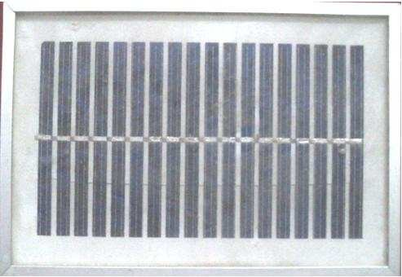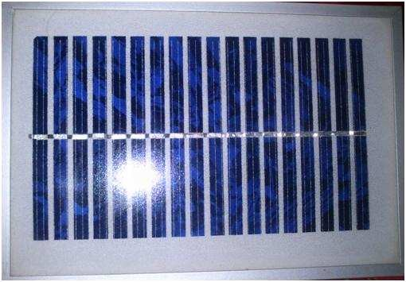

Fig. 1: Clear solar panel Fig. 2: Dusty solar panel

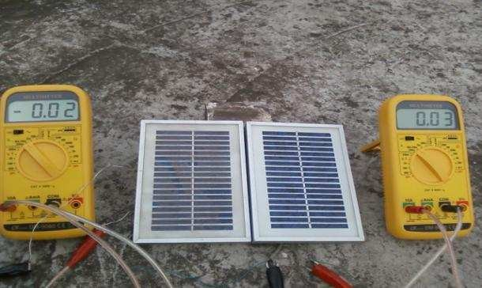

Fig. 3: process

The result: We consider a panel around the outside environment for one month to collect dust naturally. Then we collect data from dust and clean Solar panel with the help of multimeter. After collecting data we plot graph by the help of MATLAB software.

|  |  |
| --- | --- |
|  |  |
| Fig.4 Graph of Isc vs Time for Dust(o) and Clean (*) panel | Fig.5 Graph of Percentage Decrement of Isc (%) vs Time |
|  |  |
| Fig.6 Graph of Isc vs Time for Dust(o) and Clean (*) panel | Fig.7 Graph of Percentage Decrement of Power(%) vs Time |
|  |  |
| Fig.8 Graph of Power vs Time for Dust (o) and Clean (*) panel | Fig.9 I-V characteristics curve for Dust(o) and Clean (*)panel |

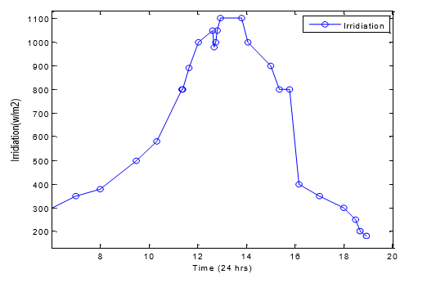  
Fig 10. Graph for Irradiation vs Time

It can be easily said that the Isc of clean panel is greater than the Isc of dusty panel.when the sun intensity is lower at (8 am to 9 am ) then the large amount percentage decrement of Isc ocuurs around 35%.But at midday the amount percentage decrement of Isc is around 20%. The output power of solar panel is related with short circuit current. So the percentage decrement of power as well as percentage decrement of Isc. From the fig. No 8 and 9 we can see that when the power of dusty panel fall then the power of clean panel does not fall. So it can be easily said that maximum point of power is reduced for dust. [3]

In conclusion, we can say that pollination should be taken into account when designing photoelectric plants. Protecting photovoltaic plants from dust should be the first priority, rather than cleaning dusty surfaces. From the above proposals, we can distinguish the following: the use of saxophones and the use of a starchy mixture in the area where solar photoelectric power stations will be built will prevent dust from rising, "hold" water in desert areas, and prevent salt from flying. Greenery will be returned to desert areas. We can get the power increase of the station from dust free panel surfaces.

References:

1. Abdushukur. OʻzME. Birinchi jild. Toshkent, 2000-yil
2. YANGI O’ZBEKISTONNING UMIDLI YOSHLARI” 1(3)-SON 2022-YIL 28-APREL 138 p.
3. I.J. Modern Education and Computer Science, 2012, 10, 26-32
4. <https://uz.wikipedia.org/wiki/Saksovul>
5. Жамият ва инновациялар – Общество и инновации – Society and innovations

Special Issue – 5 (2021) / ISSN 2181-1415 176 p.